AI-Powered Multilingual Virtual Industrial Supervisor for Smart Manufacturing Using Generative AI, Computer Vision, and Intelligent Issue Escalation

P Gopala Krishna
Dept. of Computer Science and Engineering
Gokaraju Rangaraju Institute of Engineering and Technology
Hyderabad, India gopalakrishna@griet.ac.in
Boddu Adithya Harshith
Dept. of Computer Science and Engineering
Gokaraju Rangaraju Institute of Engineering and Technology
Hyderabad, India adithyaharshithreddy@email.com
Gangaraju Manideep
Dept. of Computer Science and Engineering
Gokaraju Rangaraju Institute of Engineering and Technology
Hyderabad, India manideepgangaraju369@email.com

Harivardhan Kaveti
Dept. of Computer Science and Engineering
Gokaraju Rangaraju Institute of Engineering and Technology
Hyderabad, India harikaveti339@email.com
Rayalapuram Rishwik Reddy
Dept. of Computer Science and Engineering
Gokaraju Rangaraju Institute of Engineering and Technology
Hyderabad, India
reddyrrishwik@email.com

Abstract—Smart-manufacturing facilities increasingly adopt artificial intelligence, yet worker assistance, visual monitoring and incident handling are usually deployed as separate tools. Multilingual workforces, fragmented reporting channels and limited continuous observation can delay the communication of faults, shortages and safety hazards. This paper presents SI INDUSTRIAL SUPERVISOR, a proposed human-supervised virtual industrial supervisor that integrates multilingual voice and text interaction, Generative AI assistance grounded in approved operational records, CCTV-based person detection and tracking, structured multimodal issue reporting, role-aware escalation, and inventory and task retrieval. The architecture separates probabilistic components (speech recognition, language models, vision models) from deterministic components (validation, routing rules, database queries, audit logging) and keeps authorised personnel responsible for consequential decisions. Candidate technologies include OpenCV, a YOLO-family detector and ByteTrack; person detection and tracking are distinguished from safety-event recognition, which needs explicit rules and independent validation. The work is positioned against verified literature and commercial prototypes, and an evaluation protocol is defined covering word error rate, intent and issue-classification F1, mAP, HOTA, IDF1, event-level precision and recall, routing correctness and latency. No experimental results are reported; result tables are provided for completion once measurements exist. The intended contribution is an integrated, governed workflow and evaluation framework, not novelty of any individual model.
Keywords—Industrial Artificial Intelligence, Generative AI, Multilingual NLP, Smart Manufacturing, Computer Vision, Industrial Safety, Issue Escalation, Human–AI Collaboration.
I. Introduction
Industry 4.0 connected machines, sensors and enterprise software, and Industry 5.0 adds human-centricity, resilience and sustainability [14]. Recent reviews discuss how large language models (LLMs) may assist design, production and service functions while highlighting reliability, interpretability and integration challenges [3], [4].
On the shop floor, three problems recur in many facilities. Workers and supervisors may not share a language, and technical vocabulary adds difficulty. Task assignment, maintenance requests, inventory updates and safety reports often travel through separate channels. A human supervisor also cannot observe every area continuously, and recorded CCTV is often reviewed only after an event. These are plausible, not universal, conditions; this paper does not assume every plant exhibits them.
Individual technologies already address parts of the picture: robust multilingual speech recognition [2], retrieval-grounded generation [9], real-time detection [8], multi-object tracking [1], and YOLO-based PPE compliance detection with alarms and time-stamped reports [5], [6]. Commercial multilingual, voice-driven maintenance assistants also exist [16]–[19]. What is less clear is how such capabilities are coordinated into one auditable workflow with role-based escalation and explicit human oversight.
This paper proposes SI INDUSTRIAL SUPERVISOR as an integration architecture and evaluation framework. Its objectives are to: (O1) provide multilingual voice and text reporting; (O2) combine speech, language processing and Generative AI to interpret requests; (O3) support task guidance and troubleshooting; (O4) detect and track workers in CCTV video; (O5) define a framework for explicit, validated safety-event rules; (O6) convert reports into structured, routed issues; (O7) retrieve inventory data and detect shortages; (O8) keep humans in the loop for consequential decisions; (O9) specify a rigorous evaluation framework; and (O10) analyse limitations, privacy and deployment risks. O1–O3 are addressed in Sections V–VI, O4–O5 in Section VI-C, O6–O8 in Sections VI-D to VI-F, O9 in Section VIII and O10 in Sections X–XI. The system supports human supervisors; it is not a certified safety system.
II. Related Work
A. Smart manufacturing and LLMs
Xu et al. frame Industry 5.0 as human-centric and resilient [14]. Li et al. survey LLM use in product design, quality control, supply chain and talent management and discuss interpretability and reliability concerns; this work is a preprint [3]. Sadeqi Bajestani, Mun and Kim review LLMs in smart manufacturing with emphasis on human-in-the-loop roles, trust and validation [4]. A survey of industrial large models categorises pre-training, fine-tuning and retrieval-augmented generation [7], and Ma and Zheng review LLMs for Industry 5.0 [10]. These works support grounding the LLM in approved data and keeping humans involved; they do not report an integrated vision-plus-escalation platform.
B. Speech, retrieval and hallucination
Whisper trains multilingual, multitask models on 680,000 hours of weakly supervised audio and reports competitive zero-shot results on standard benchmarks [2]. Benchmark accuracy does not guarantee accuracy under factory noise, accents, code-switching or technical vocabulary, so in-domain evaluation is required. Retrieval-augmented generation conditions output on retrieved documents [9], while hallucination surveys show that unsupported output remains a general risk [15].
C. Multilingual industrial assistants
Non-peer-reviewed sources describe multilingual or voice-driven industrial assistants: Gefran GAIA [16], WAFIOS myWAFIOS.ai [17], an OXmaint white paper describing English/Hindi voice access, hazard reporting, audit logs and role-based access [18], and Vicomtech operator assistants [19]. These are vendor or project descriptions rather than independent evaluations, but they show that a multilingual industrial assistant is not novel in itself.
D. Vision for industrial and construction safety
YOLO casts detection as single-pass regression for real-time use [8]. Delhi et al. fine-tune YOLOv3 for hard-hat and safety-jacket compliance, with an alarm and time-stamped report intended for a safety workflow [5]. Fadhilla et al. compare YOLOv10 and YOLOv11 on 16,568 annotated images and report YOLOv11s as best (mAP50 0.718, precision 0.804) [6]. A 2026 pilot adds tracking-based rolling averages and SQL logging but identifies individuals by facial recognition [20]; this paper deliberately does not adopt that. These studies concern construction PPE, so transfer to a specific factory needs new data and validation.
E. Tracking and metrics
ByteTrack associates nearly every detection box, including low-score boxes, with tracklets and reports 80.3 MOTA, 77.3 IDF1 and 63.1 HOTA on MOT17 at about 30 FPS on a V100 [1]. DeepSORT adds appearance features to SORT [13]. Identities are assigned within a sequence; cross-camera re-identification is a separate task. Tracking is evaluated with CLEAR MOT [11], IDF1 [12] and HOTA [21].
Table I. Verified studies most relevant to the design
Ref. | Work (venue, year) | Method; dataset / metrics | Relevance
[1] | ByteTrack (ECCV 2022) | BYTE association; MOT17/MOT20; MOTA, IDF1, HOTA | Candidate tracker
[2] | Whisper (ICML 2023) | Weakly supervised multilingual ASR; WER benchmarks | Candidate ASR
[3] | LLMs for Manufacturing (arXiv 2024, preprint) | Survey; not applicable | Motivation
[4] | HITL and LLMs in smart manufacturing (J. Manuf. Syst. 2026) | Scoping review; not applicable | Human oversight
[5] | PPE compliance, YOLOv3 (Front. Built Environ. 2020) | Transfer learning; alarm + report; details in paper | Vision-to-alert
[6] | PPE with YOLOv10/11 (Sistemasi 2025) | 16,568 images; mAP50, precision | Detector choice
[16]–[19] | Vendor / applied assistants | Not peer-reviewed; metrics not reported | Shows overlap

III. Research Gap and Contributions
Within the sources reviewed, individual capabilities are well represented: LLM surveys [3], [4], [7], commercial multilingual assistants [16]–[19], PPE detection with alarms [5], [6] and tracking [1]. No peer-reviewed, openly evaluated study was found that combines (a) multilingual worker interaction, (b) multimodal structured issue creation, (c) CCTV-derived events, (d) role-based escalation and (e) inventory retrieval under explicit human authorisation. The search was limited (no IEEE Xplore, ACM or Scopus access), so this is a hypothesis requiring systematic review, and commercial products may already integrate some elements. The claim is therefore restricted to the sources reviewed.
Candidate contributions, none proven until evaluated: C1 a unified supervision workflow (architectural); C2 multilingual multimodal issue reporting with uncertainty handling (methodological); C3 vision-to-incident integration using validated event rules (implementation); C4 role-aware escalation by category, severity, zone and confidence (methodological); C5 human-supervised Generative AI combining validated data, deterministic rules and approvals (architectural); C6 an integrated evaluation framework (experimental). Each requires the evidence listed in Section VIII.
IV. Problem Formulation
Users are workers, supervisors, maintenance, warehouse and safety staff, managers and administrators. Inputs are voice, text, images, video frames {f₁,…,fₜ}, and task and inventory records. Outputs are multilingual replies, issue records, routed notifications, inventory alerts, dashboards and audit logs.
Let a report r have language ℓ, modality m and content x. The system estimates an intent i with confidence cᵢ, a category k with confidence cₖ and a severity s. A routing function R(k, s, z, c) returns a recipient role for zone z. An action is executed automatically only if it belongs to an approved low-risk set Aₐᵤₜₒ and c ≥ τ; otherwise it goes to human triage. Consequential actions (emergency dispatch, changing inventory, authorising hazardous work) are never in Aₐᵤₜₒ. Constraints include noisy audio and video, limited connectivity, privacy requirements, latency targets [TO CONFIRM] and approved procedures that the AI must not override.
V. Proposed System Architecture
The system has seven layers: (1) input sources (voice, text, images, CCTV or recorded video, task and inventory records); (2) input processing (audio preprocessing, speech-to-text, language identification, text normalisation, frame extraction, schema validation); (3) AI processing (NLU and intent, LLM, retrieval, detection, tracking, issue classification, severity, rule-based event detection); (4) orchestration; (5) operations modules (communication, task assistance, CCTV monitoring, issue management, inventory, safety notification); (6) storage; and (7) outputs (replies, guidance, confirmations, alerts, dashboards, history). Every component is proposed unless confirmed as implemented [TO CONFIRM].
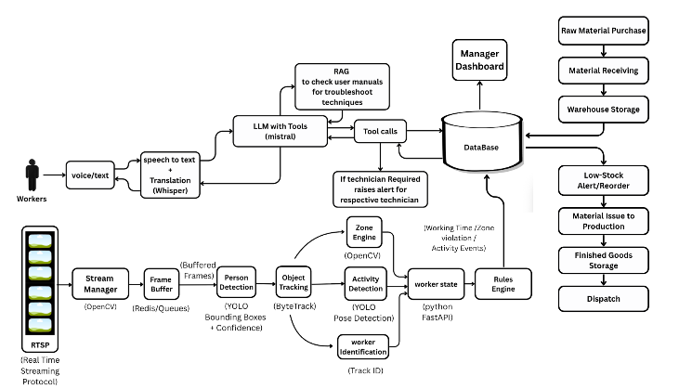
Fig. 1. High-level architecture of SI INDUSTRIAL SUPERVISOR (proposed).
A single model does not perform every function. Specialised models handle ASR, detection and tracking; the LLM interprets free text, summarises and drafts replies from retrieved context; conventional code handles validation, routing, thresholds, permissions, de-duplication and logging; and database queries, not the LLM’s memory, are the source of truth for stock levels and task status. Because LLM output is probabilistic [15], safety-relevant behaviour uses explicit rules, schema-validated outputs, confidence thresholds and human acknowledgement, consistent with human-in-the-loop recommendations [4].
Storage holds users and roles, tasks, issues, inventory, event metadata, notifications, resolutions and references to evidence. Role-based access control limits CCTV, worker-linked and edit rights; records are append-only for audit; retention periods follow site policy and law [TO CONFIRM]. No specific database is assumed.
VI. Methodology
Table II. Candidate technologies (versions unspecified)
Component | Candidate | Main limitation | Evaluated by
Video I/O | OpenCV | Decode latency, codecs | FPS, drops
Detector | YOLO-family [8] | Occlusion, lighting, domain shift | P, R, mAP
Tracker | ByteTrack [1] | IDs are sequence-scoped | HOTA, IDF1, ID switches
ASR | Multilingual, e.g. Whisper [2] | Noise, accents, code-switching | WER, CER
LLM | Unspecified | Hallucination, latency | Faithfulness audit
Storage | Relational or document DB | Data quality | Retrieval correctness

A. Requirements and input acquisition
Requirements are gathered from workers, supervisors, maintenance, warehouse and safety staff to define roles, scenarios, languages and an escalation matrix. Recorded test video and live CCTV are different regimes: recorded files allow repeatable benchmarking with ground truth, whereas live feeds add jitter, dropped frames, camera drift and authorisation requirements. Results from one must not be reported as the other.
B. Multilingual processing and Generative AI assistance
Audio is preprocessed, transcribed and language-identified; text is normalised. Low ASR confidence, an unsupported language or unrecognised vocabulary triggers clarification or human routing instead of a guess. Requests are mapped to intents (troubleshooting, task assistance, inventory inquiry, safety report, other) as schema-validated structured output. The LLM receives the request, retrieved approved content and fixed instructions, and must answer only from that context or state that it cannot. Controls are retrieval grounding [9], constrained JSON outputs, validation of referenced IDs against the database, refusal to authorise hazardous operations and human escalation. These reduce but do not eliminate hallucination [15]. AI recommendations are labelled as such and are distinct from authorised assignments.
C. Computer vision processing
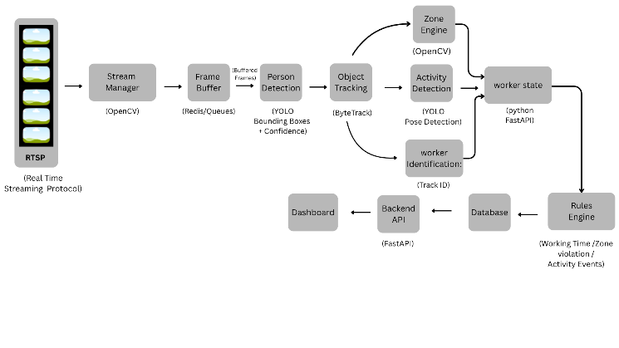
Fig. 2. CCTV detection and tracking workflow.
For each frame the detector returns boxes and scores; the tracker associates high- and low-score boxes with tracklets [1] to give track IDs. For a person foot-point p and a predefined polygon Z, the predicate in(p, Z) is evaluated. A candidate event is raised only if a defined rule holds for N consecutive frames, which reduces single-frame noise. Detector outputs are not safety decisions; the rule layer and human review convert them into incidents.
Person detection, tracking, PPE detection, restricted-zone entry, fall detection, unsafe posture and abnormal-behaviour detection are distinct tasks with different data and metrics. Only those implemented and validated may be listed as capabilities; the rest are future work. Track IDs do not identify the same person across cameras or files, and no facial recognition or biometric identification is proposed.
D. Issue creation, classification and escalation
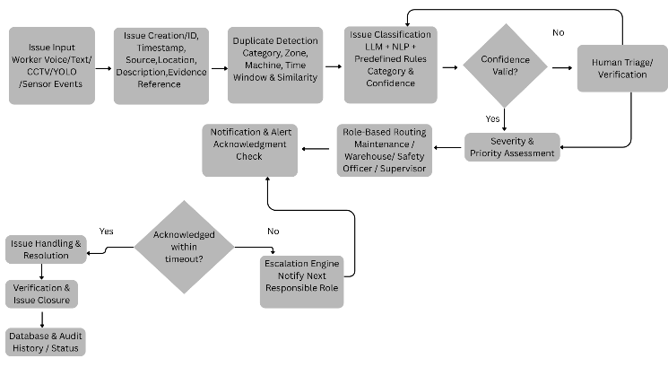
Fig. 3. Issue classification and escalation workflow.
An issue record holds ID, source, timestamp, reporter role (if authorised), category, description, evidence reference, severity, assigned role, status, escalation history and resolution. Categories are equipment fault, material shortage, operational difficulty, maintenance request, safety hazard, task question and other. New reports are compared with open issues by category, zone or machine, time window and similarity; above a threshold they are merged with evidence appended or flagged for human confirmation. If the top category confidence is below τₖ or the top two categories are close, the issue goes to a triage queue.
The proposed default routing table sends machine malfunctions to maintenance, inventory shortages to warehouse staff, safety hazards to the safety officer, task questions to the assigned supervisor, and critical emergencies to designated emergency personnel following the site’s predefined procedure. This is a proposed rule table, not an operating one. Severity, zone, urgency and confidence modify priority and recipients. The LLM is never the sole authority for declaring an emergency, and certified alarm systems remain primary. Notifications require acknowledgement within a severity-dependent timeout, otherwise they escalate to the next role; every step is logged.
function route(issue):
if issue.conf < TAU_C or issue.cat is None:
return TRIAGE_QUEUE
role = ROUTING_TABLE[issue.cat]
if issue.sev == CRITICAL:
return [role, EMERGENCY_PROCEDURE_CONTACT]
return [role] # ack req.; timeout->next
Algorithm 1. Routing rule (specification, not confirmed code).
E. Inventory and task integration
Three operations are distinguished: reading stock and task data (allowed for authorised roles), recommending a reorder or update when quantity falls below a threshold, and modifying records, which requires human approval. If live synchronisation is not implemented, this module is a proposed read-only prototype using static or periodically imported data [TO CONFIRM].
F. Logging, monitoring and testing
The system logs inputs (or hashes and pointers where privacy requires), model outputs and confidences, routing decisions, errors, latencies and resolution status. Subsystems are tested individually and then end to end (Section VIII).
VII. Implementation
This section must be completed from the real codebase. The table lists what must be supplied; nothing here states that a component exists.
Table III. Implementation facts to be supplied
Item | Value
Programming language and frameworks | [TO CONFIRM]
Detector model, weights, input size, thresholds | [TO CONFIRM]
Tracker library, version, parameters | [TO CONFIRM]
ASR model/service and languages | [TO CONFIRM]
LLM provider, version, prompt and retrieval design | [TO CONFIRM]
Database and schema | [TO CONFIRM]
Notification channel | [TO CONFIRM]
Live CCTV or recorded video; hardware | [TO CONFIRM]

The vision loop reads each frame, detects people above a confidence threshold, updates the tracker, tests foot-points against zone polygons, increments a per-track counter and raises a candidate event with a clip reference when the counter reaches N. The conversation pipeline receives input, transcribes and identifies language, classifies intent and category with confidence, retrieves approved context, generates a structured response, validates it against schema and permissions, acts (answer, create issue or escalate), replies in the worker’s language and logs. ASR failure, malformed output or timeout causes a repeat request or human handover. Issue handling runs create, categorise, assign severity, select recipient, notify, await acknowledgement, update status and close with audit history.
VIII. Experimental Setup (Proposed Protocol)
No experiments are reported. The protocol below should be run and Table V filled with measured values. Any synthetic data must be labelled as such. The setup must specify hardware, software versions, test site, dataset sources, sample sizes, annotation procedure and inter-annotator agreement, and splits kept disjoint by video, session and speaker. Bootstrap confidence intervals and paired tests should be used against baselines.
Table IV. Evaluation plan
Subsystem | Metrics
Speech / language | WER, CER, intent accuracy, macro-P/R/F1, latency, task-completion rate, human-rated relevance, stratified by language, noise and accent
Detection | Precision, recall, mAP on annotated target-camera frames
Tracking | HOTA, IDF1, MOTA, identity switches, continuity [1], [11], [12], [21]
Safety events | Event-level precision and recall per specific rule, false alarms per hour, detection latency, missed-event rate
Issues / routing | Category P/R, macro-F1, severity performance, routing accuracy, correct-recipient rate, time to route, duplicate rate, human-correction rate
Inventory / task | Retrieval correctness, status consistency, threshold-alert accuracy, workflow completion
End to end | Latency, scenario completion, error propagation, human interventions, resource use, usability (e.g., SUS)

Baselines are used only where they can be implemented fairly: manual reporting, text-only reporting, a non-multilingual workflow, standalone detection without incident integration, and rule-only routing versus AI-assisted classification. Superiority is claimed only if measured data support it, and person-detection accuracy is never reported as safety-event accuracy.
IX. Results and Discussion
Results are unavailable. Table V is a template awaiting measured data; all cells are empty by design.
Table V. Results template
Result set | Columns | Status
Speech and language | Language, condition, WER, CER, intent F1, latency | Not yet evaluated
Issue classification | Category, precision, recall, F1, support | Not yet evaluated
Object detection | Model, precision, recall, mAP50, mAP50–95 | Not yet evaluated
Tracking | Tracker, HOTA, IDF1, MOTA, ID switches | Not yet evaluated
Safety events | Rule, event P, event R, false alarms/h, latency | Not yet evaluated
Routing | Category, accuracy, time to route, correction rate | Not yet evaluated
Latency and resources | Stage median and 95th percentile; CPU, GPU, memory | Not yet evaluated
Baseline comparison | Method, key metrics | Not yet evaluated

Once data exist, the discussion should analyse error propagation (for example an ASR error causing a wrong category and recipient), failure cases such as occlusion, night shifts and accents, the trade-off between alarm sensitivity and false-alarm burden, and whether the frequency of human intervention is acceptable.
X. Security, Privacy and Ethical Considerations
Data collection is minimised to what each function needs, preferring event metadata and short clips over continuous recording, with defined retention and deletion for audio, video and evidence, and worker notification and approvals as required by law and policy. Facial recognition and covert surveillance are not default features. Safety assistance is kept separate from automated employee evaluation, and event records are not treated as misconduct findings without human review, since false positives and misses are unavoidable. Access uses role-based control, authenticated and encrypted communication and audit logs for CCTV access, worker-linked data and every task or inventory change; the AI cannot modify inventory or tasks without authorised approval. Model risks include ASR errors, LLM hallucination [15], vision false positives and negatives, bias across languages, accents and conditions, and unreliable emergency escalation. Mitigations are confidence thresholds, human triage, acknowledgement with timeout escalation, redundancy with certified alarms and periodic re-validation.
XI. Limitations and Future Work
Performance varies across languages, accents and noise. LLMs can produce incorrect or unsupported answers. Detection degrades with occlusion, poor lighting, camera motion and unusual angles, and tracking can lose or switch identities and does not give cross-camera re-identification. CCTV may not show the cause of an incident, and each safety event needs a precise definition and independent validation. Misclassification may cause unnecessary escalation or missed notifications, inventory answers are only as reliable as the underlying records, real-time operation may need substantial compute and network resources, and privacy obligations constrain data collection. The effectiveness of the integrated workflow is unproven until measured, and the literature search behind the gap is limited.
Future work includes more languages and better ASR, RAG over approved documentation, integration with maintenance-management, MES and ERP systems, broader validated safety events including PPE, multi-camera tracking and re-identification, predictive maintenance, demand forecasting, digital twins, edge and offline operation, explainability, human-feedback learning and trials under realistic industrial conditions. These are not current capabilities.
XII. Conclusion
This paper proposed SI INDUSTRIAL SUPERVISOR, an integrated, human-supervised architecture for multilingual worker communication, grounded Generative AI assistance, CCTV-based person detection and tracking, structured issue management, role-aware escalation and inventory retrieval. The verified sources show that each capability, and some commercial multilingual assistants, already exist, so the proposed contribution is the governed integration and its evaluation. No performance claims are made. The next steps are to complete the implementation details, collect in-domain data, run the protocol of Section VIII and extend the literature search before asserting any gap or advantage.

References
[1] Y. Zhang et al., “ByteTrack: Multi-object tracking by associating every detection box,” in Proc. ECCV, 2022, doi: 10.1007/978-3-031-20047-2_1.
[2] A. Radford, J. W. Kim, T. Xu, G. Brockman, C. McLeavey, and I. Sutskever, “Robust speech recognition via large-scale weak supervision,” in Proc. ICML, PMLR vol. 202, 2023, pp. 28492–28518.
[3] Y. Li et al., “Large language models for manufacturing,” arXiv:2410.21418, 2024 (preprint).
[4] M. Sadeqi Bajestani, D. Mun, and D. Kim, “Human-in-the-loop and large language models in smart manufacturing: Current applications, challenges, and perspectives,” J. Manuf. Syst., vol. 86, pp. 913–941, 2026, doi: 10.1016/j.jmsy.2026.04.027.
[5] V. S. K. Delhi, R. Sankarlal, and A. Thomas, “Detection of personal protective equipment (PPE) compliance on construction site using computer vision based deep learning techniques,” Front. Built Environ., vol. 6, art. 136, 2020, doi: 10.3389/fbuil.2020.00136.
[6] M. Fadhilla, S. Sapitri, and R. Wandri, “Deep learning-based identification of personal protective equipment in construction area,” Sistemasi: J. Sist. Inf., vol. 14, no. 4, 2025.
[7] “Industrial large model: A survey,” MATEC Web Conf., vol. 401, art. 10009, 2024, doi: 10.1051/matecconf/202440110009 (authors to be added).
[8] J. Redmon, S. Divvala, R. Girshick, and A. Farhadi, “You only look once: Unified, real-time object detection,” in Proc. IEEE CVPR, 2016, pp. 779–788.†
[9] P. Lewis et al., “Retrieval-augmented generation for knowledge-intensive NLP tasks,” in Proc. NeurIPS, 2020.†
[10] Y. Ma and S. Zheng, “Leveraging large language models in next generation intelligent manufacturing: Retrospect and prospect,” J. Manuf. Syst. (year, volume to be confirmed).†
[11] K. Bernardin and R. Stiefelhagen, “Evaluating multiple object tracking performance: The CLEAR MOT metrics,” EURASIP J. Image Video Process., 2008.†
[12] E. Ristani, F. Solera, R. Zou, R. Cucchiara, and C. Tomasi, “Performance measures and a data set for multi-target, multi-camera tracking,” in ECCV Workshops, 2016.†
[13] N. Wojke, A. Bewley, and D. Paulus, “Simple online and realtime tracking with a deep association metric,” in Proc. IEEE ICIP, 2017.†
[14] X. Xu, Y. Lu, B. Vogel-Heuser, and L. Wang, “Industry 4.0 and Industry 5.0—Inception, conception and perception,” J. Manuf. Syst., vol. 61, 2021.†
[15] Z. Ji et al., “Survey of hallucination in natural language generation,” ACM Comput. Surv., vol. 55, no. 12, 2023.†
[16] Gefran, “GAIA: AI conversational assistant for Industry 5.0,” product page, gefran.com (non-peer-reviewed).
[17] WAFIOS, “myWAFIOS.ai,” wafios.com/en/ai (non-peer-reviewed).
[18] OXmaint Factory AI, “OXmaint AI + Meta glasses: Industry 4.0 white paper,” v1.0, Dec. 2025 (non-peer-reviewed).
[19] Vicomtech, “Human-machine dialogue and interaction systems,” vicomtech.org (non-peer-reviewed).
[20] “A deep learning-driven system for real-time detection, identification, and documentation of unsafe behaviors in construction: Case study,” in Proc. ASC 62nd Annu. Int. Conf., vol. 7, pp. 970–978, 2026 (authors to be added).
[21] J. Luiten et al., “HOTA: A higher order metric for evaluating multi-object tracking,” Int. J. Comput. Vis., vol. 129, 2021.†
† Cited from prior knowledge; verify title, authors, venue and DOI before submission. Items [1]–[7] and [20] were checked against publisher, proceedings or arXiv records.

